Part1.

Question 1:

(1)

SELECT * FROM
(
(SELECT RatingValue, Title, Publisher, Pages
FROM Book3
ORDER BY RatingValue DESC nulls last
OFFSET 0 ROWS
FETCH NEXT 15 ROWS ONLY
)
UNION
(
SELECT RatingValue, Title, Publisher, Pages
FROM Book3
ORDER BY RatingValue
OFFSET 0 ROWS
FETCH NEXT 10 ROWS ONLY
)
)
ORDER BY RatingValue DESC
;

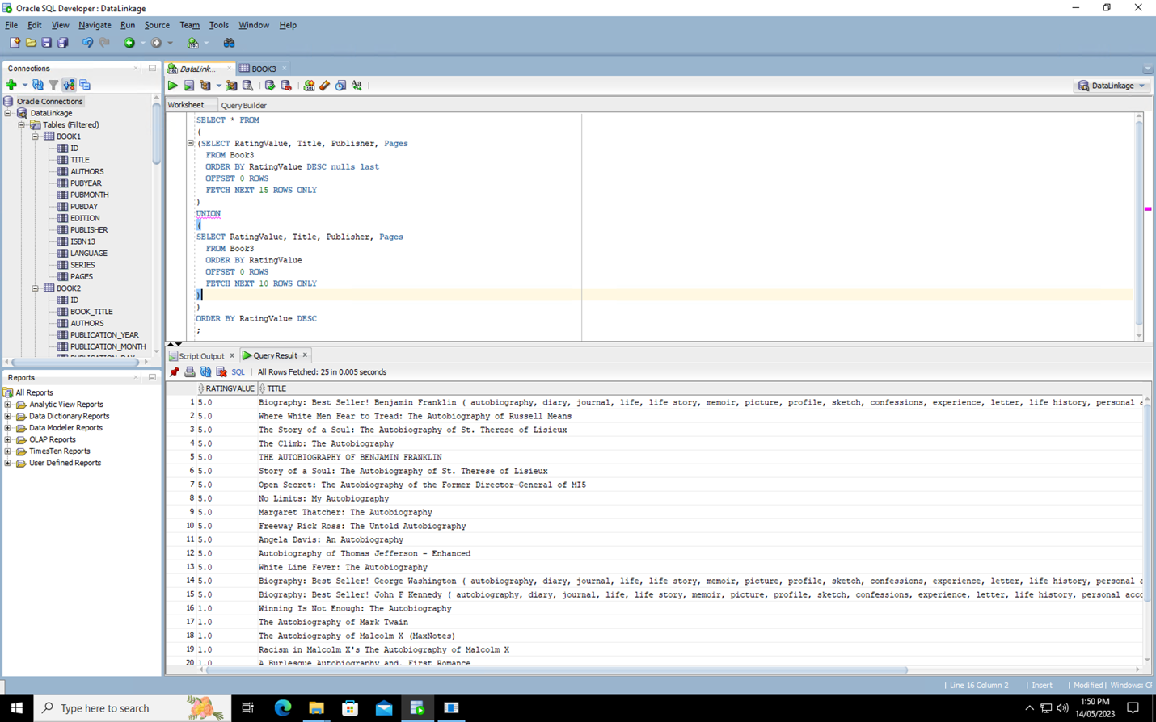

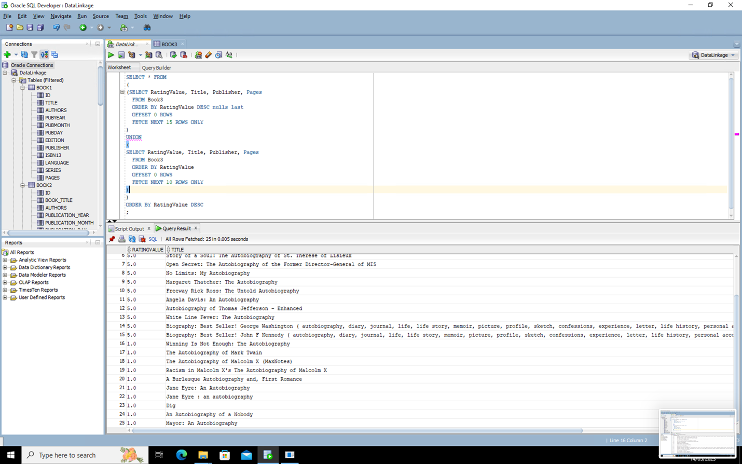

(2)

The above query is using only the Book3 table schema because it is selecting from the `Book3` table and using columns `RatingValue`, `Title`, `Publisher`, and `Pages` that exist in the `Book3` schema. No other table schemas are mentioned or used in the query.

Question 2:

(1)

A vertical fragmentation strategy should be used to fragment Book3 table, because both queries have different and distinct attributes, and this strategy can ensure the goal of A to handle each query by a dedicated local site (no information needed from the other site).

The schemas:
- Fragment 1 (query 1): Book3_1 (ID, Title, Author1, Author2, Author3, Publisher)
- Fragment 2 (query 2): Book3_2 (ID, Date, Pages, HardcoverPrice, EbookPrice)

(2)

This set of predicates is not valid, because there is a gap between the range of 600 and 800 (incompleteness), which means that any book with a page number between 601 to 800 is not be included in any fragment.

The True False Table:

 | Pages ≤ 200 | 200 < Pages ≤ 600 | Pages > 800
1 | T | T | T
2 | T | T | F
3 | T | F | T
4 | T | F | F
5 | F | T | T
6 | F | T | F
7 | F | F | T
8 | F | F | F

- The Fragment 1 Predicate:
  - True: Pages ≤ 200
  - False: Pages > 200

- The Fragment 2 Predicate:
  - True: 200 < Pages ≤ 600
  - False: Not (200 < Pages) or NOT (Pages ≤ 600), which means 200 ≥ Pages or Pages > 600

- The Fragment 3 Predicate:
  - True: Pages > 800
  - False: Pages ≤ 800

The 8 Combinations:

1 | Pages ≤ 200 AND  200 < Pages ≤ 600 AND  Pages > 800 | Impossible, because Pages ≤ 200 and Pages > 800 cannot coexist.
2 | Pages ≤ 200 AND  200 < Pages ≤ 600 AND  Pages ≤ 800 | Impossible, because Pages ≤ 200 and Pages ≤ 800 cannot coexist.
3 | Pages ≤ 200 AND  (200 ≥ Pages or Pages > 600) AND  Pages > 800 | Impossible, because Pages ≤ 200 and Pages > 800 cannot exist.
4 | Pages ≤ 200 AND  (200 ≥ Pages or Pages > 600) AND  Pages ≤ 800 | Possible, this is Pages ≤ 200.
5 | Pages > 200 AND  200 < Pages ≤ 600  AND  Pages > 800 | Impossible, because Pages ≤ 600 and Pages > 800 cannot exist.
6 | Pages > 200 AND  200 < Pages ≤ 600 AND  Pages ≤ 800 | Possible, this is 200 < Pages ≤ 600.
7 | Pages > 200 AND  (200 ≥ Pages or Pages > 600) AND  Pages > 800 | Possible, this is Pages > 800.
8 | Pages > 200 AND  (200 ≥ Pages or Pages > 600) AND  Pages ≤ 800 | Possible, this is 600 < Pages ≤ 800.

The valid predicate set:
- Fragment 1: Pages ≤ 200
- Fragment 2: 200 < Pages ≤ 600
- Fragment 3: 600 < Pages ≤ 800
- Fragment 4: Pages > 800

The insertion process for a new record after the valid predicate set is made:
For inserting a new record into Book3, the process would depend on the number of pages in the book:
- If the book has 200 pages or less, it would be inserted into Fragment 1.
- If the book has more than 200 but less than or equal to 600 pages, it would be inserted into Fragment 2.
- If the book has more than 600 but less than or equal to 800 pages, it would be inserted into Fragment 3.
- If the book has more than 800 pages, it would be inserted into Fragment 4.

Part2.

Question 3:

(1)

A Data Warehouse Schema:

- Fact Table: SalesData
  - DayID (foreign key)
  - PublisherID (foreign key)
  - LanguageID (foreign key)
  - Sales (measure)

- Dimension Tables:
  - DayDimension
    - DayID (primary key)
    - Day
    - Month
    - Year

  - PublisherDimension
    - PublisherID (primary key)
    - PublisherName

  - LanguageDimension
    - LanguageID (primary key)
    - Language

Among all the dimension tables and the fact table, the fact table (SalesData) will likely have the most records. because a fact table in a data warehouse design generally contains the measurable, quantitative data (in this case, Sales) about a business, recorded at the most granular level, which usually results in a large number of records.

Question 4:

(1)

- The advantages of building a bitmap index:
  - It is highly compressed, thus saving space.
  - It is very efficient for read operations.
  - It performs well for low cardinality columns (i.e., columns with a small number of distinct values).
  - It is especially efficient for operations that involve multiple conditions (such as AND, OR conditions).

- High cardinality columns are not suitable for the bitmap index. (i.e., columns with a large number of distinct values), or for columns in tables that undergo frequent modifications (inserts, updates, deletes), as this can lead to significant overhead in maintaining the index.

(2)

Bitmap indices for both "Publisher" and "Language":

- Publisher Bitmap Index:

Publisher | AAAI Press | Springer International Publishing | Springer London | IEEE Computer Society Press
1 | 1 | 0 | 0 | 0
2 | 0 | 1 | 0 | 0
3 | 0 | 0 | 1 | 0
4 | 0 | 0 | 0 | 1
5 | 1 | 0 | 0 | 0
6 | 0 | 1 | 0 | 0
7 | 0 | 0 | 1 | 0
8 | 0 | 0 | 0 | 1

- Language Bitmap Index:

Record | English | Spanish
1 | 1 | 0
2 | 1 | 0
3 | 1 | 0
4 | 1 | 0
5 | 0 | 1
6 | 0 | 1
7 | 0 | 1
8 | 0 | 1

(3)

To find the total sales of "English" books published by "AAAI Press", a bitwise AND operation on the "AAAI Press" bitmap from the Publisher bitmap index and the "English" bitmap from the Language bitmap index would be performed. This will result in a bitmap where every '1' corresponds to a record where the publisher is "AAAI Press" and the language is "English". These '1' positions are the IDs or the pointers to the records in the fact table, and these can be used to retrieve the corresponding sales figures and add them up.

Part 3.

Question 5:

(1)

The common attributes from each schema together (Book1, Book2, Book3, and Book4) are:
- id
- Title
- Author(s)
- Publication Date
- Publisher
- ISBN13
- Pages

The Global Schema: GlobalBook (id, Title, Author, Publication Date, Publisher, ISBN13, Pages)

The Author attribute may need to be extended in the global schema to accommodate the multiple authors, as found in Book3.

(2)

Structural Heterogeneity: The structural heterogeneity refers to the differences in the structure or the format of the similar data across the different databases.

Example: The representation of the date in each schema. Book1 has the publication date split into the 3 different attributes (pubyear, pubmonth, pubday) whereas Book4 represents it as the single attribute (Publication_Date).

Resolution: Convert all the dates to a common format during the integration. For example, the full date format used in Book4 might be chose. This would involve concatenating the year, the month, and the day from Book1 into the single date format.

(3)

Semantic Heterogeneity: The semantic heterogeneity refers to the differences in the meaning, the interpretation, or the use of the similar data across the different databases.

Example: The attribute "Author" could be interpreted differently in the different schemas. In Book1 and Book2, "authors" is a single field, presumably containing one or multiple authors as a single string. However, in Book3, each author has a separate field (Author1, Author2, Author3).

Resolution: A standard format should be decided for storing the author data. One way could be to standardise the representation to always have the authors in a single field, with the multiple authors separated by a delimiter like a comma. During the data integration process, the data from Book3 would then be concatenated and separated by the chosen delimiter to match the format in the global schema.

Part4.

Question 6:

(1) & (2) & (3)

#Import pandas
import pandas as pd

#Read the "Book3.csv" file into a DataFrame
df = pd.read_csv("Book3.csv")

#Sample the records whose id is the multiple of 100
sample_set = df[df['1'] % 100 == 0]

#Get the number of records in the sample set
num_records = len(sample_set)

#Print the number of records in the sample set
print("Number of records in the sample set:", num_records)

#Count the number of fields containing NULL values in the sample set
null_fields = sample_set.isnull().sum().sum()

#Print the number of fields in the sample set
print("Number of fields containing NULL values:", null_fields)

#Calculate the total number of opportunities
total_opportunities = sample_set.shape[0] * sample_set.shape[1]

#Calculate the Empo
empo = (null_fields / total_opportunities) * 10**6

#Print the Empo
print("Empo:", empo)

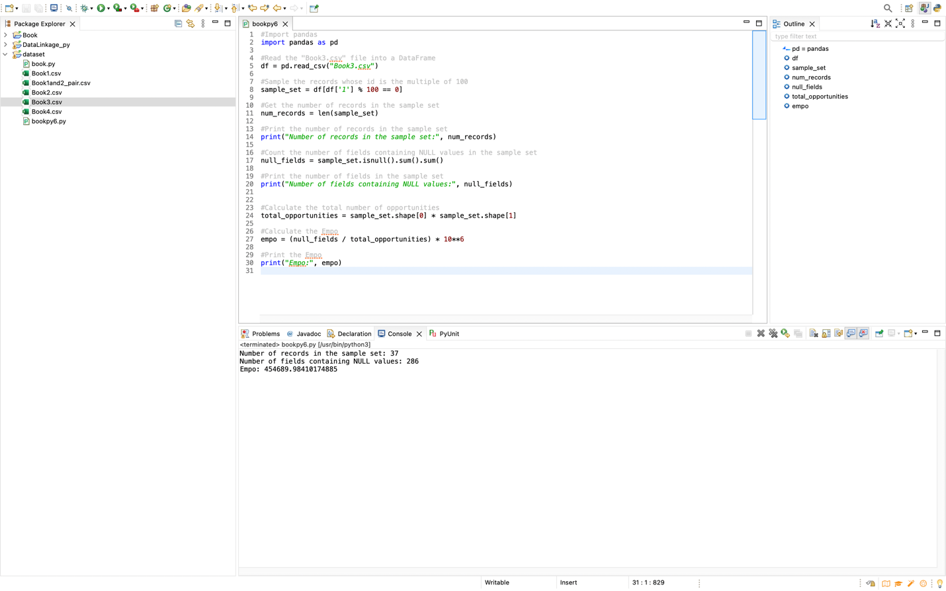

Question 7:

(1)

The Jaccard distance is more likely to regard them as similar (between two approaches
of edit distance and Jaccard distance).

- The Edit Distance: The edit distance measures the minimum number of the operations (insertions, deletions, substitutions) required to transform one string into another. In this case, the edit distance between the two author strings would consider the differences in the order of the names and the presence of the extra spaces or characters. The edit distance approach would likely regard the two author strings as dissimilar due to the differences in the ordering of the names and the presence of the additional characters.

- The Jaccard Distance: The Jaccard distance measures the dissimilarity between two sets based on the intersection and union. In this case, we can treat the author names as sets of words. The Jaccard distance approach would consider the similarity based on the common words between the two author strings. Since both author strings contain the same names, although in the different orders, the Jaccard distance approach is more likely to regard them as similar.

In this case, the Jaccard distance function is more likely to regard them as similar. This is because the author strings are composed of the same unique tokens ("Richmond Shee", "Kirtikumar Deshpande", and "K. Gopalakrishnan"), they are just ordered differently. The Jaccard distance measures the similarity between the two sets, and since the sets of tokens in these two strings are identical, it will consider them to be similar. The edit distance, on the other hand, considers the order of the characters in the strings, and since the authors are ordered differently in these two strings, it will consider them to be less similar.

(2)

- The precision = 0.1608876560332871
- The recall = 0.5
- The Fmeasure = 0.24344176285414482

- book.py

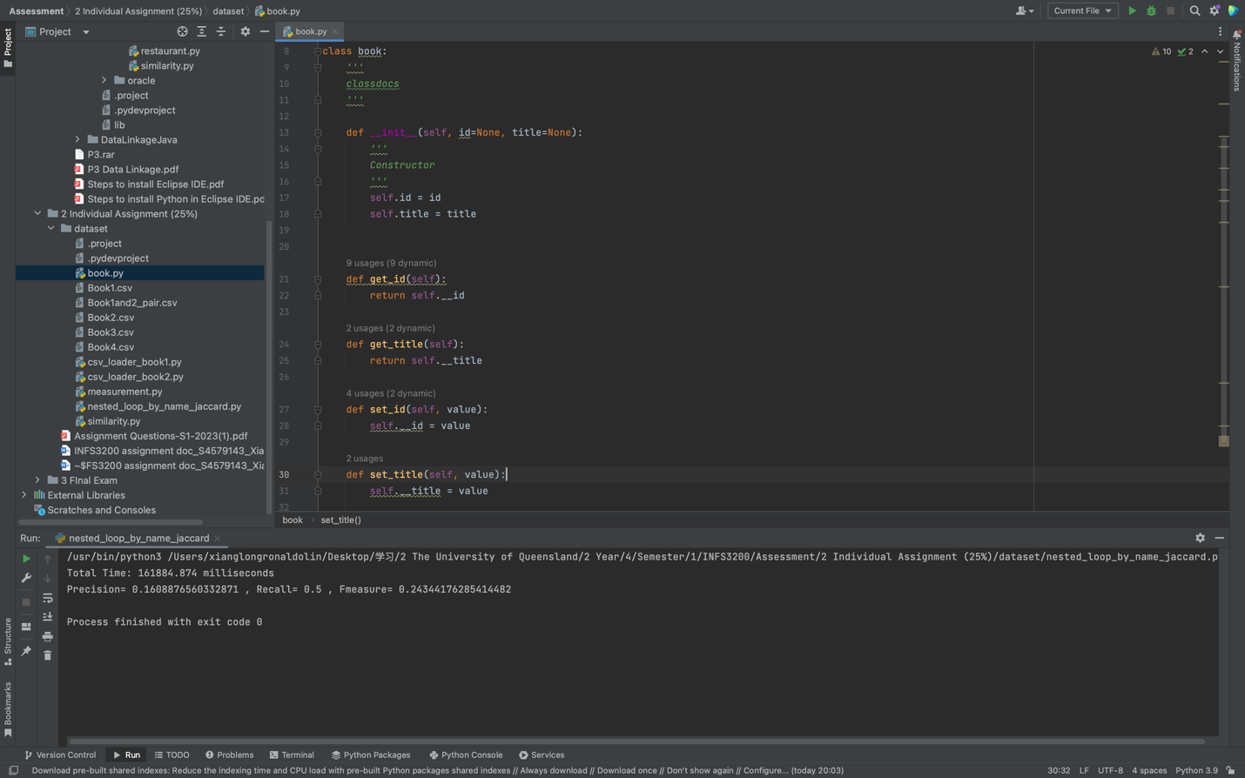

- csv_loader_book1.py

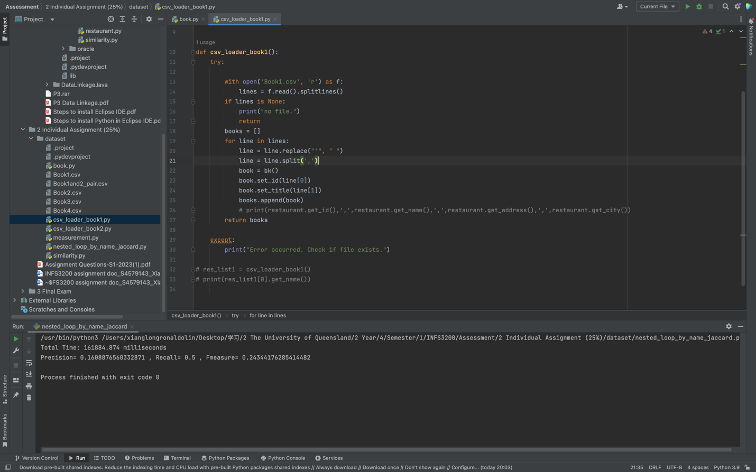
- csv_loader_book2.py

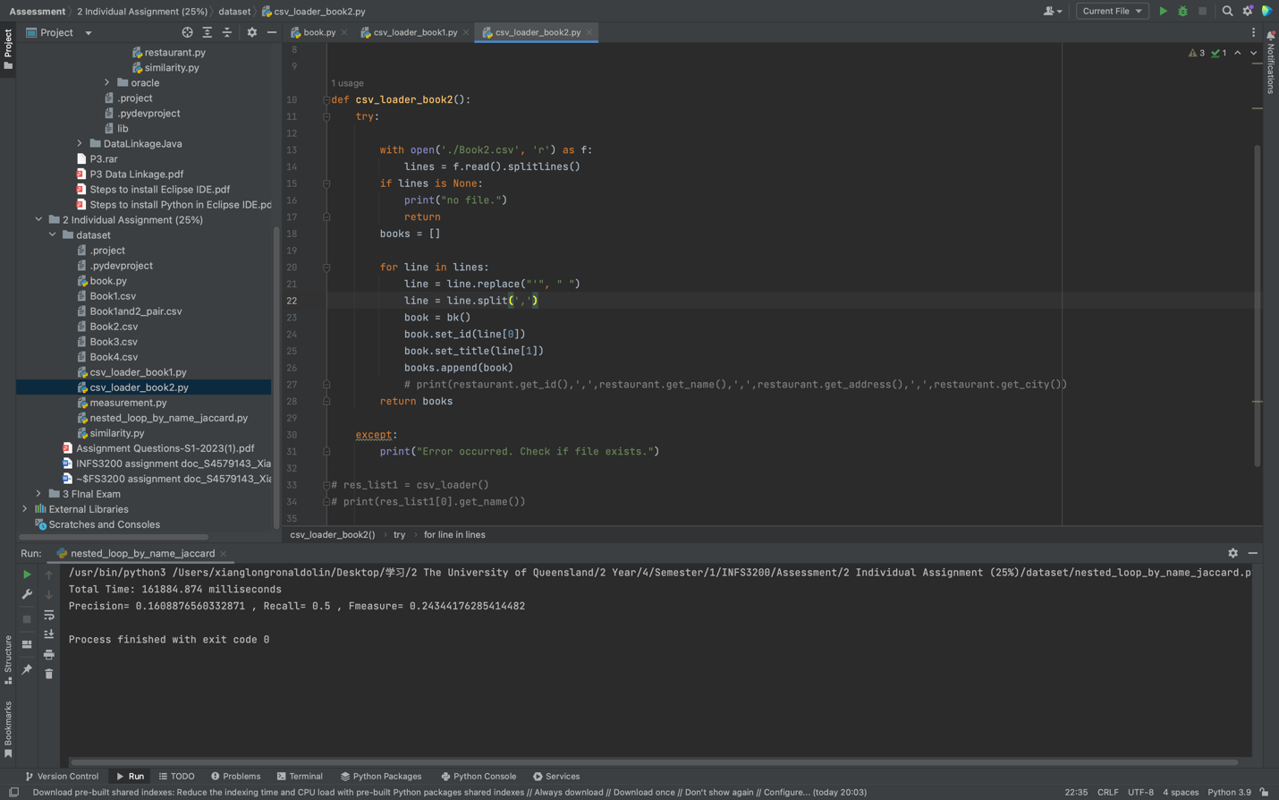

- measurement.py

- 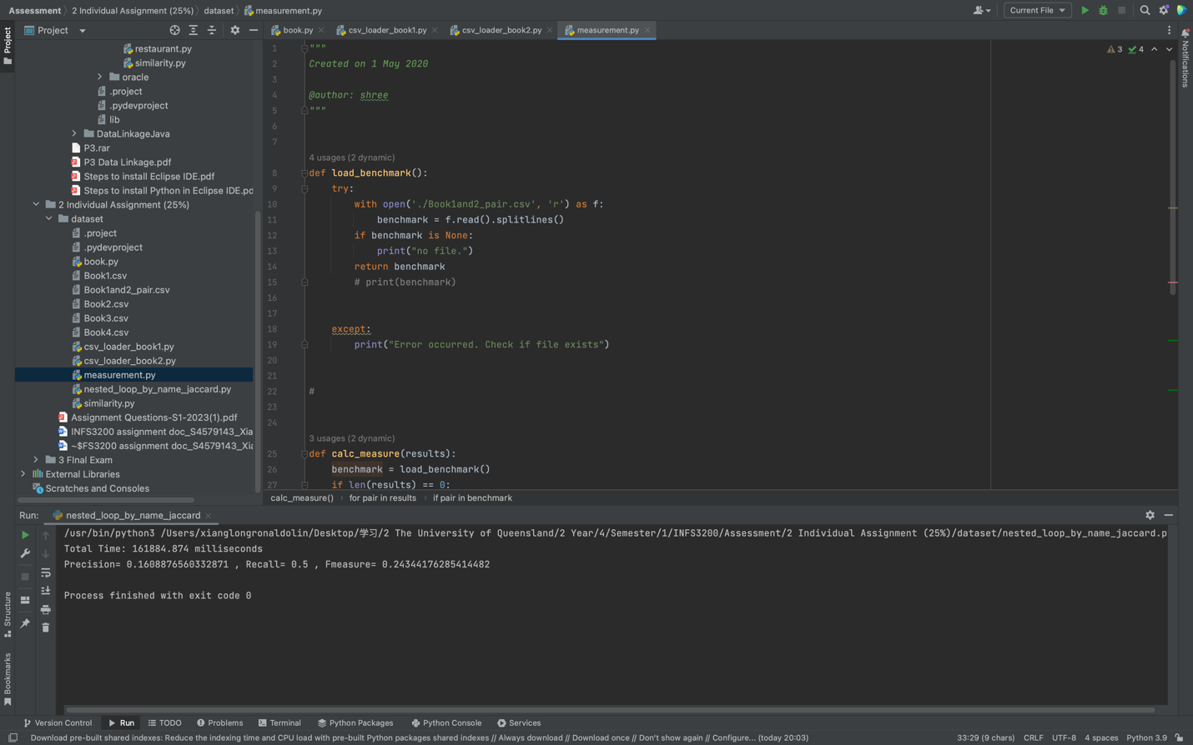

- 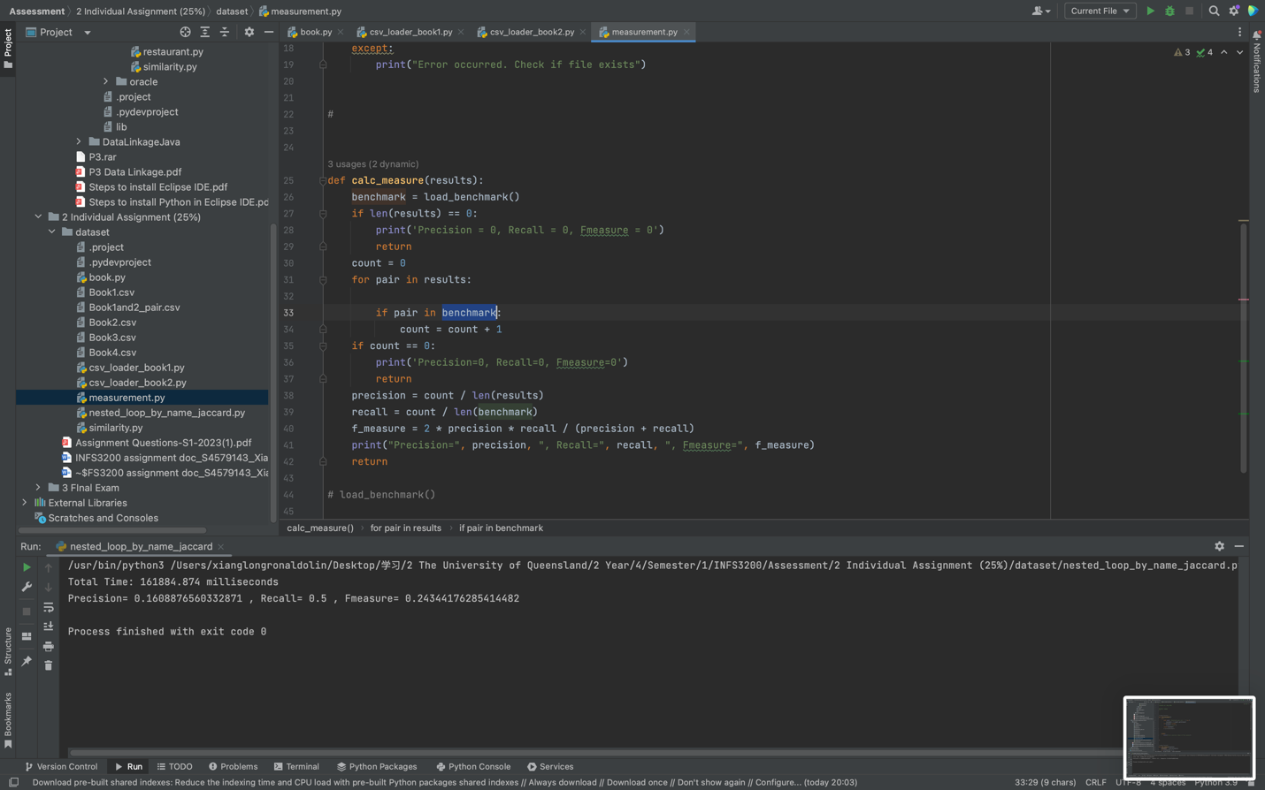

- nested_loop_by_name_jaccard.py

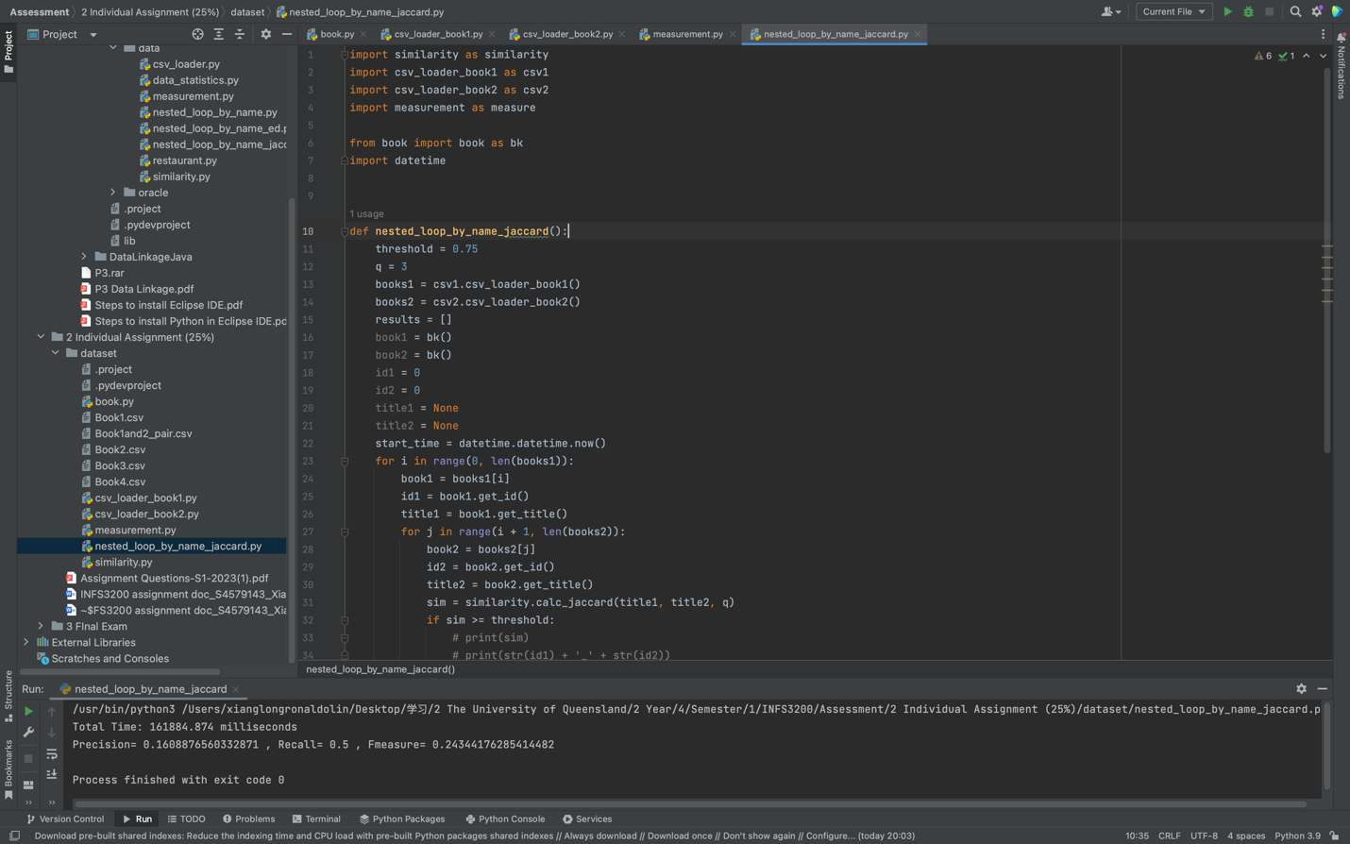
- similarity.py

